Platform/Lakehouse Demo certification

Objective & tips:
- Keep the platform demo (both slides and code) in less than 25 minutes.
- Do not explain how things work, explain why they are useful.
- Idea is not to cover everything, but rather show an end-to-end Lakehouse story.
- Focus is on the Lakehouse storytelling, not individual features and functions.
- This guide is a version of how a platform demo may look like. You might not be able to hit all of the talking points or may want to add your own—this is ok.

Demo resources
The demo leverages the dbdemos library and the content in go/field-demos. We strongly recommend you use the following content, using for example E2 field eng or CS2E workspace.
Demo deck:
Lakehouse Demo Certification: Deck
Prerequisite:
From E2 field eng or CS2E workspace, create a notebook to setup the demo assets with dbdemos.
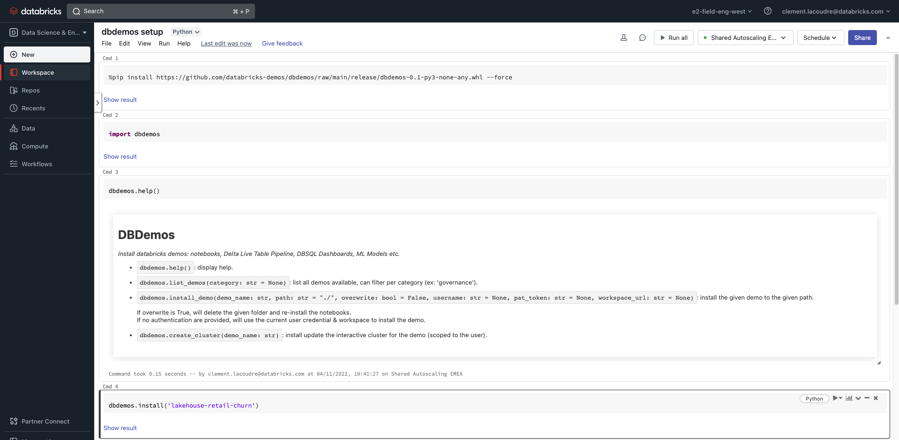
Note: Make sure you are using one of the workspace supported by go/field-demos

Demo Script:

Step 0: Start from the final objective: open Customer Prediction Churn - Universal Dashboard. Browse the dashboard’s KPI: classic and “predictive” KPIs coming from ML models.
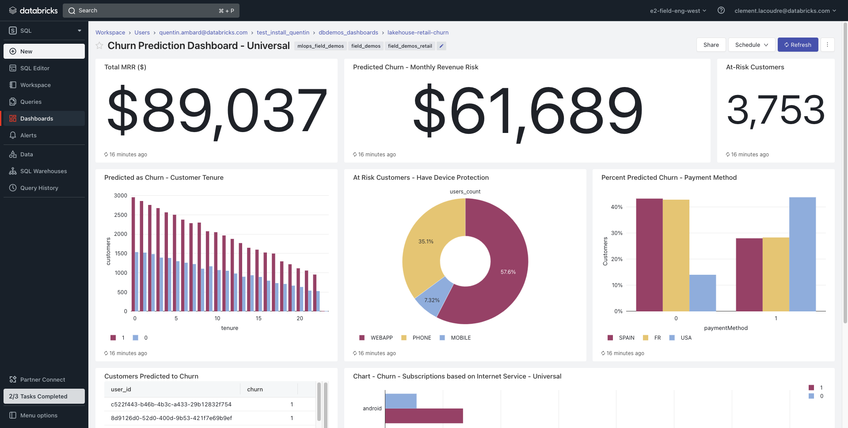

Step 1: Open 00-churn-introduction-lakehouse. Recapitulate the 4 steps the data team needs to achieve to make the dashboard.

Step 2: Open 01.1-DLT-churn-SQL. Mention data engineers' common challenges and how DLT ease their life. Explain (high-level) the SQL steps until the ML model is loaded as a Spark UDF (5/).
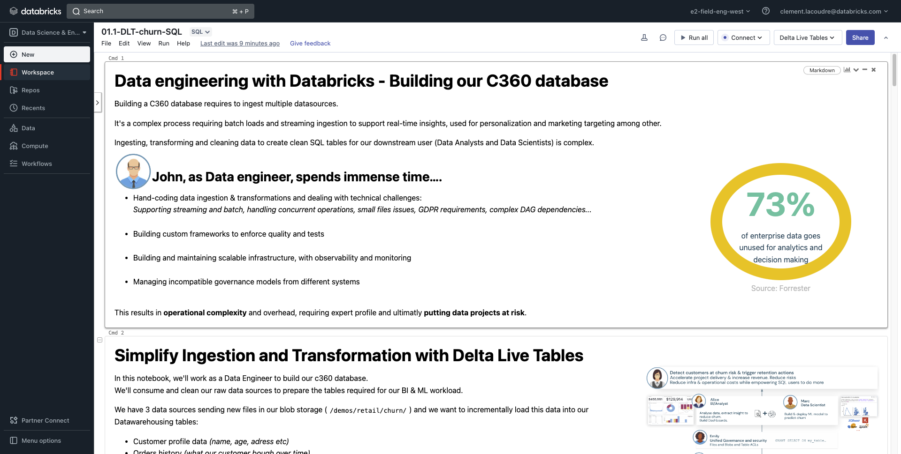

Step 3: Change to the ML Persona.
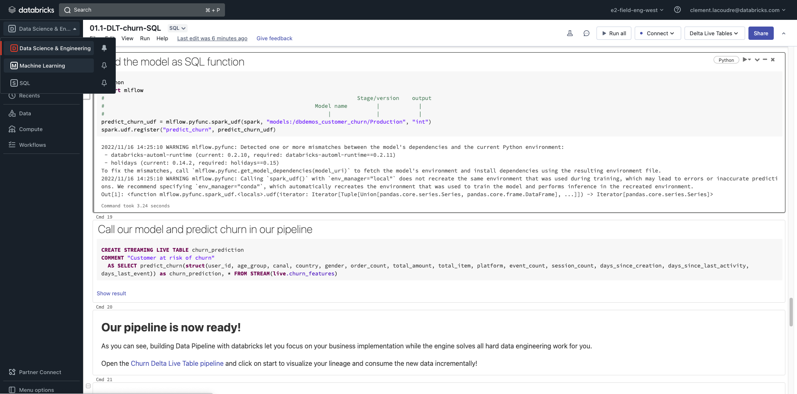

Step 4: Go to the Model Registry. Look for dbdemos_customer_churn.
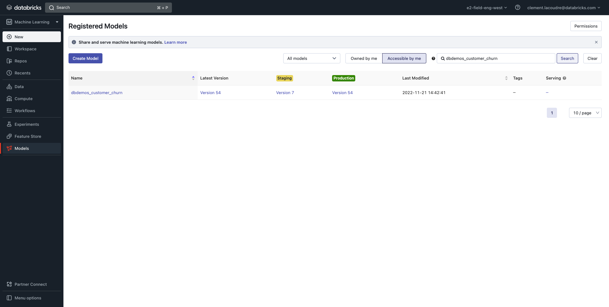

Step 5: Select dbdemos_customer_churn model. Elaborate on model versioning which enhances DS collaboration and model reproducibility.
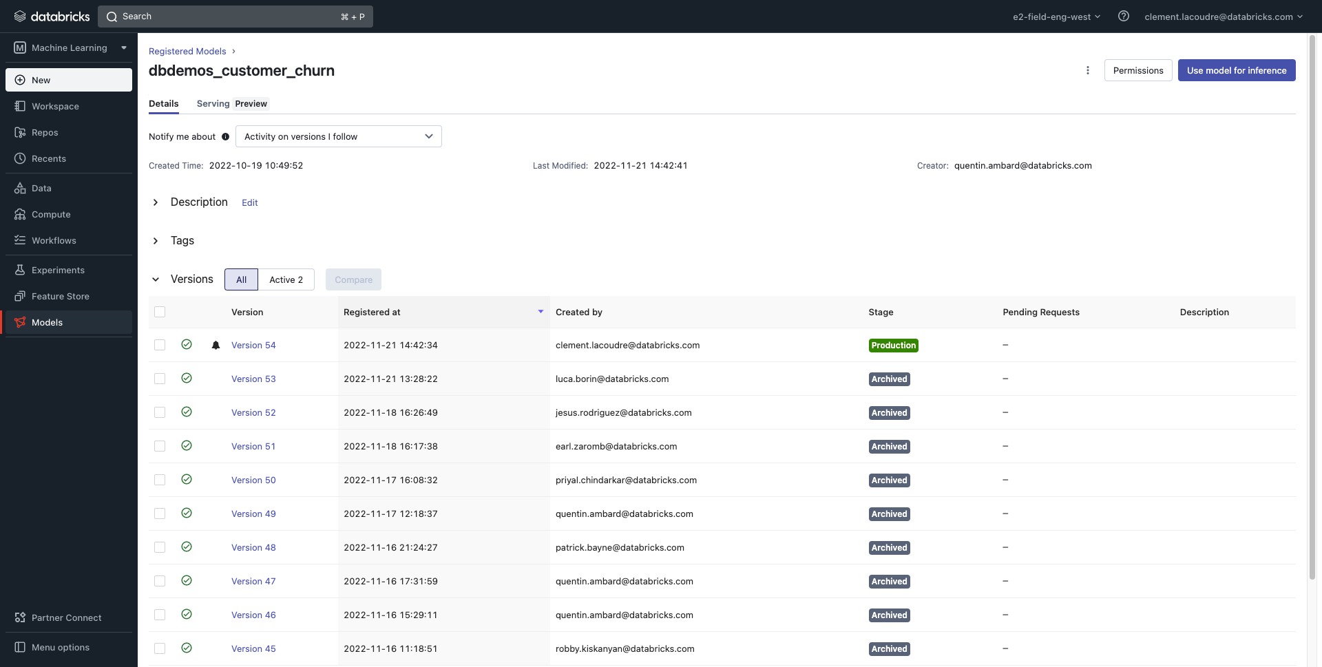

Step 6: Click on the latest version. Show the inputs and output so that DE/DA knows how to score the model.
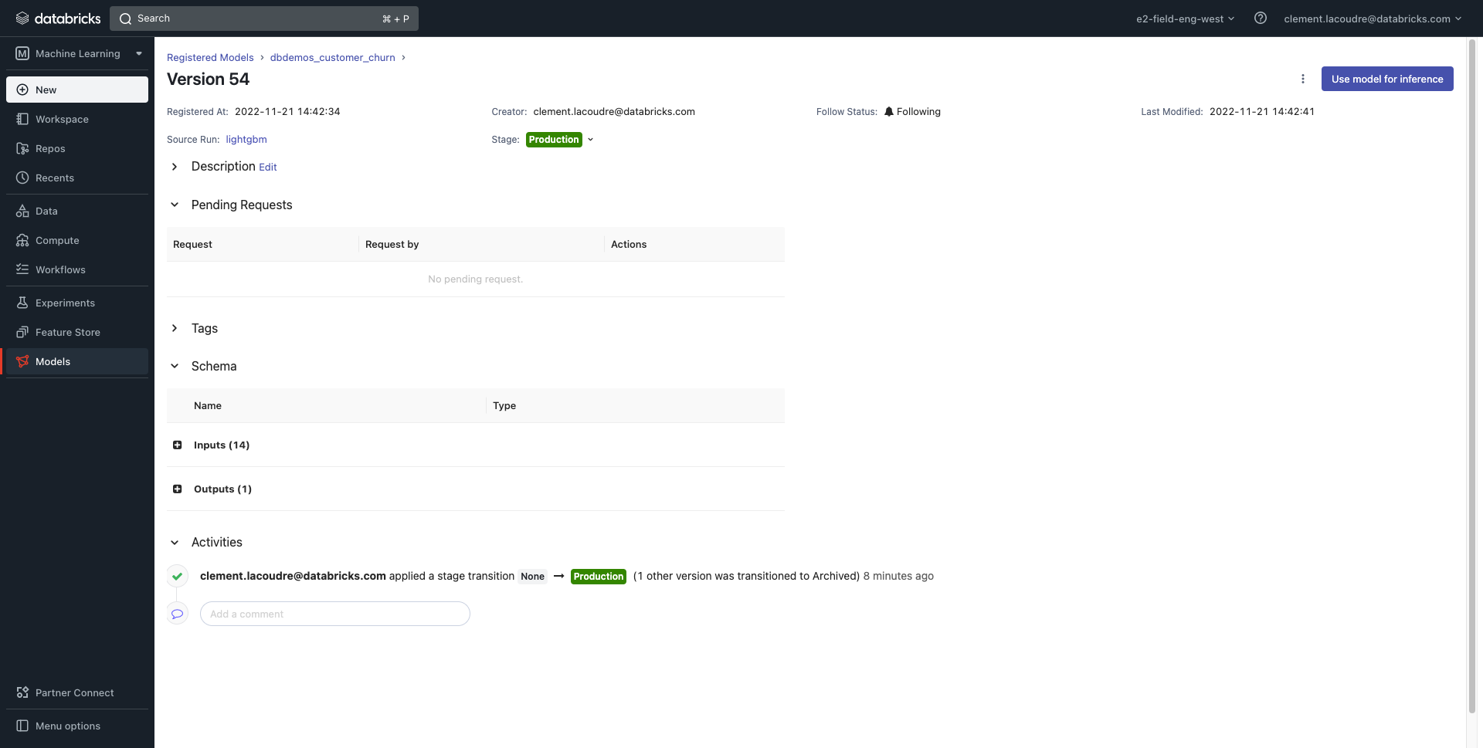

Step 7: Select the source run (lightgbm). Browse the artifacts explaining Data Scientists can document their experiments which helps collaboration.
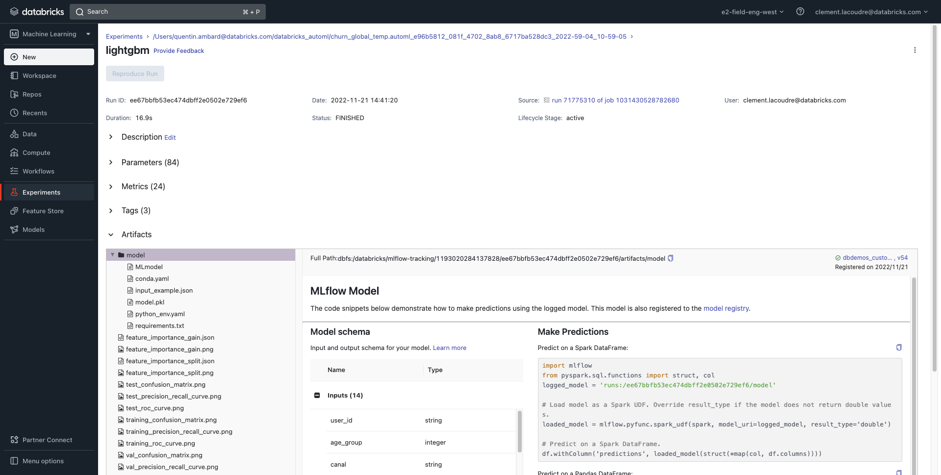

Step 8: Open source job’s run and briefly scroll the notebook mentioning AutoML capabilities.
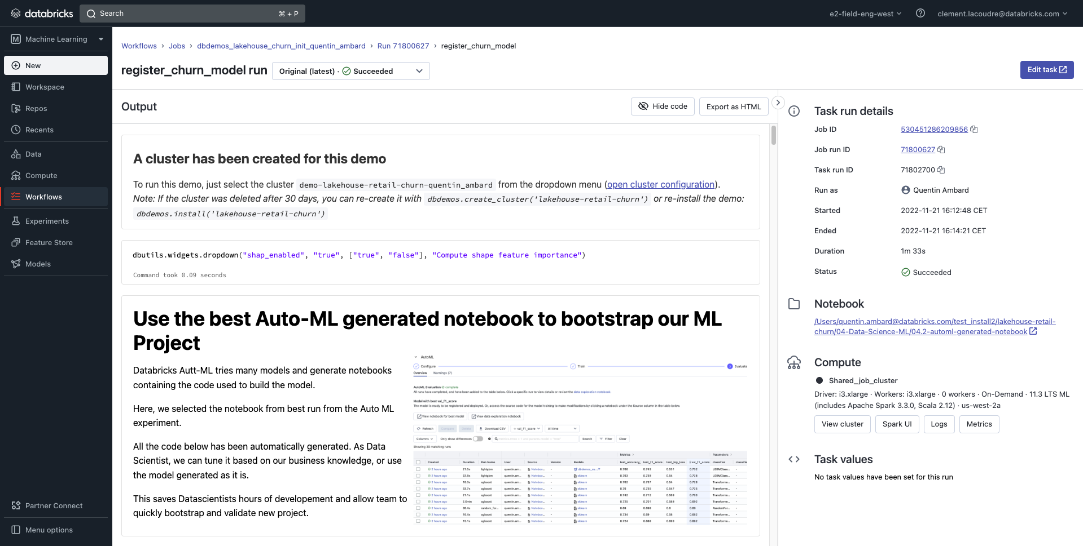

Step 9: Come back to 01.1-DLT-churn-SQL. Show on the last SQL statement how the model can be scored out of the box with plain SQL.
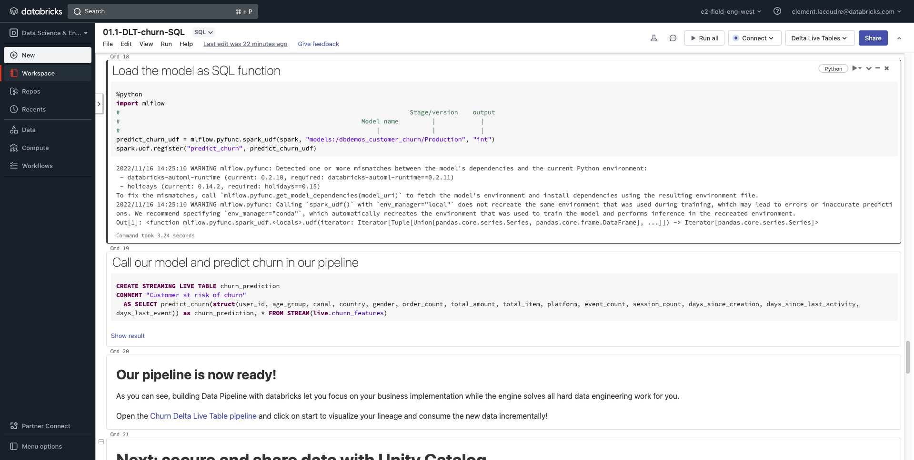

Step 10: Show the DLT DAG:
- lineage automatically generated
- data quality enforcement
- logs and pipeline metadata recorded to a delta table
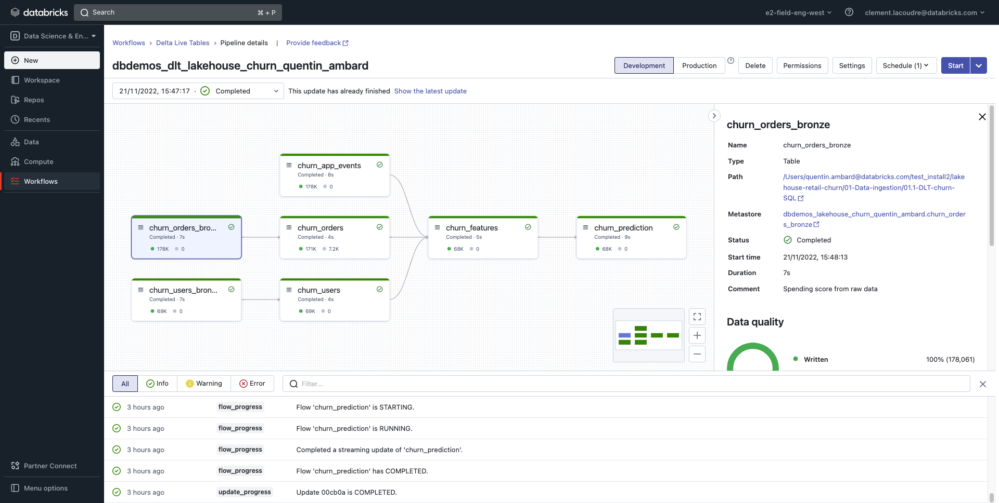

Step 11: Show the DLT - Retail Data Quality Stats dashboard. Our pipeline now reliably produces gold data. What if I want a Secure Data platform with proper Data Governance?
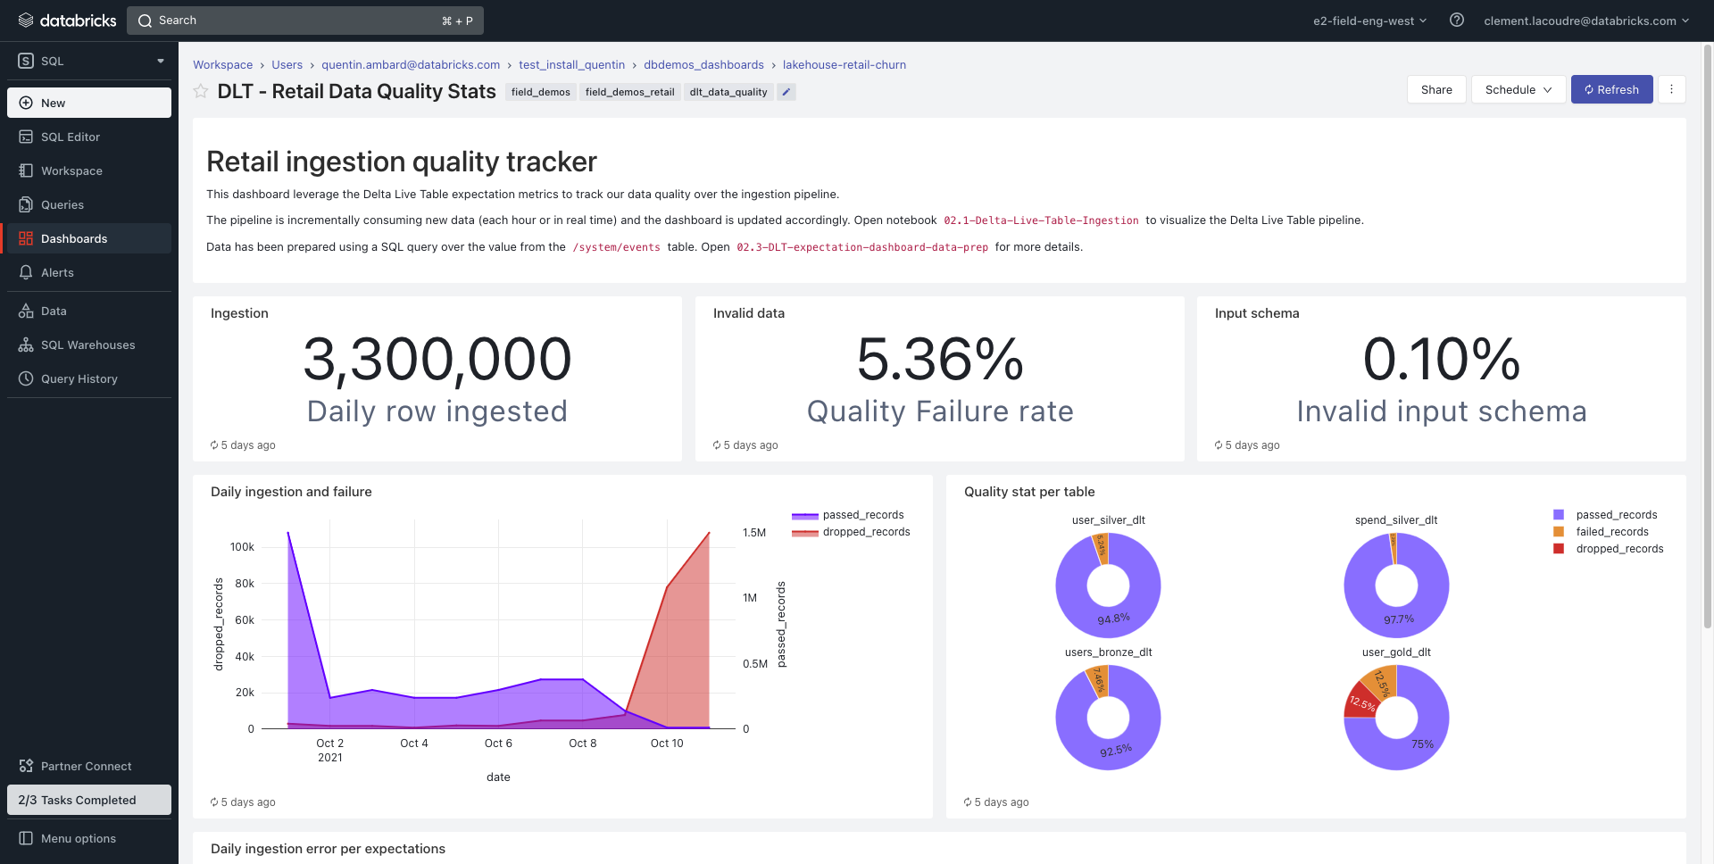

Step 12: Change to the SQL Persona. Look for the catalog dbdemos. Open it and browse securable objects showing permissions and lineage UC’s capabilities.
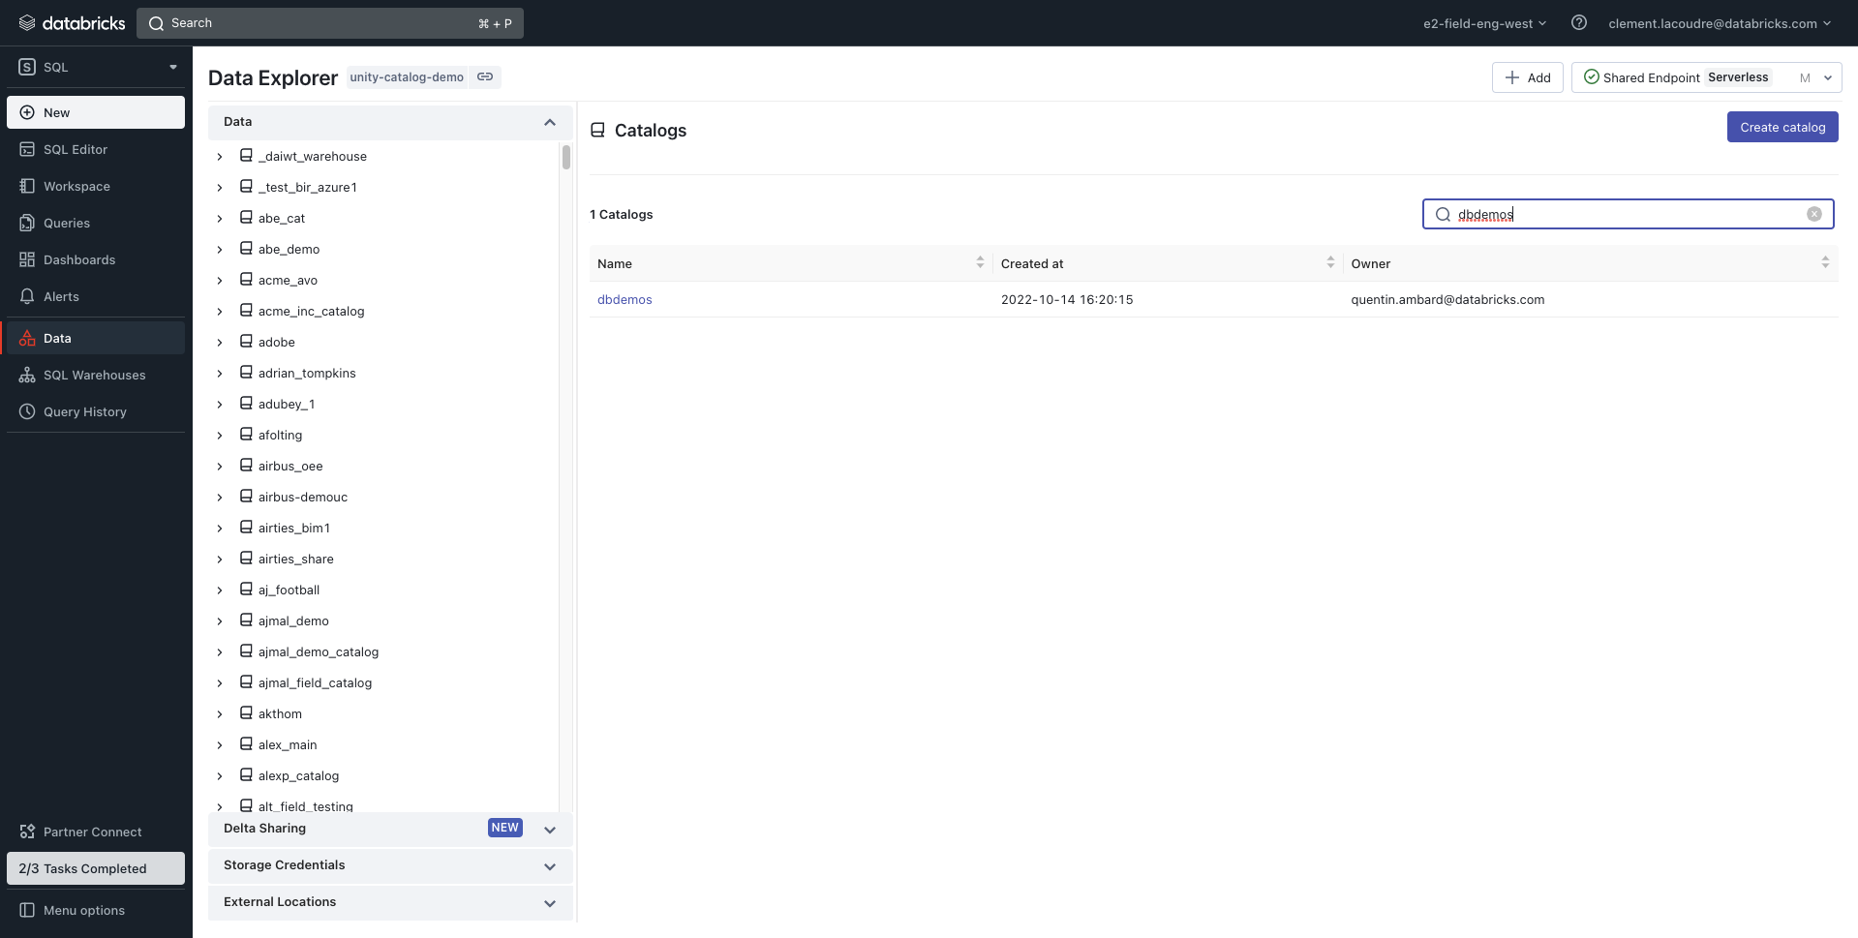

Step 13: Open the SQL editor interface. On the left, look for catalog dbdemos, schema lakehouse_churn. Query SELECT * FROM churn_users;
Show how easily an Analyst can do ad-hoc queries on top of the data while accessing only the data he has access to.
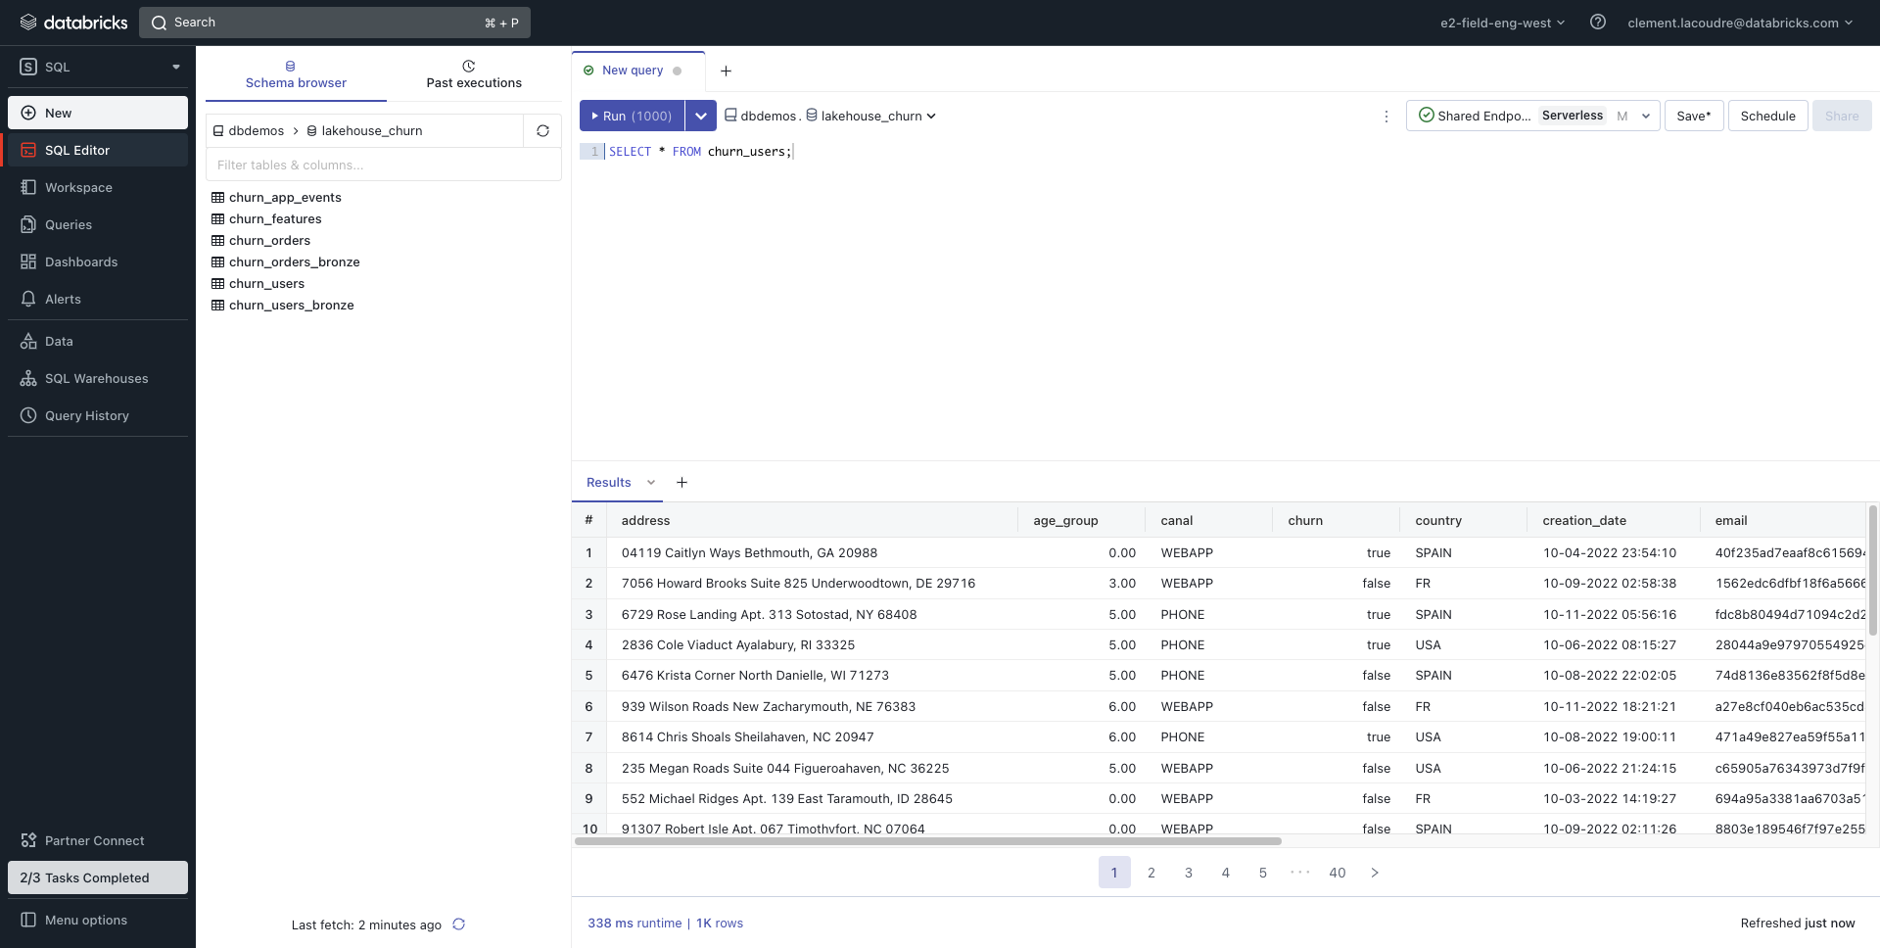

Step 14: Mention the DA can build Visualisations and Dashboards from the query. Build a simple visualization (visualization type: pie, X: churn, Y: count(user_id)).
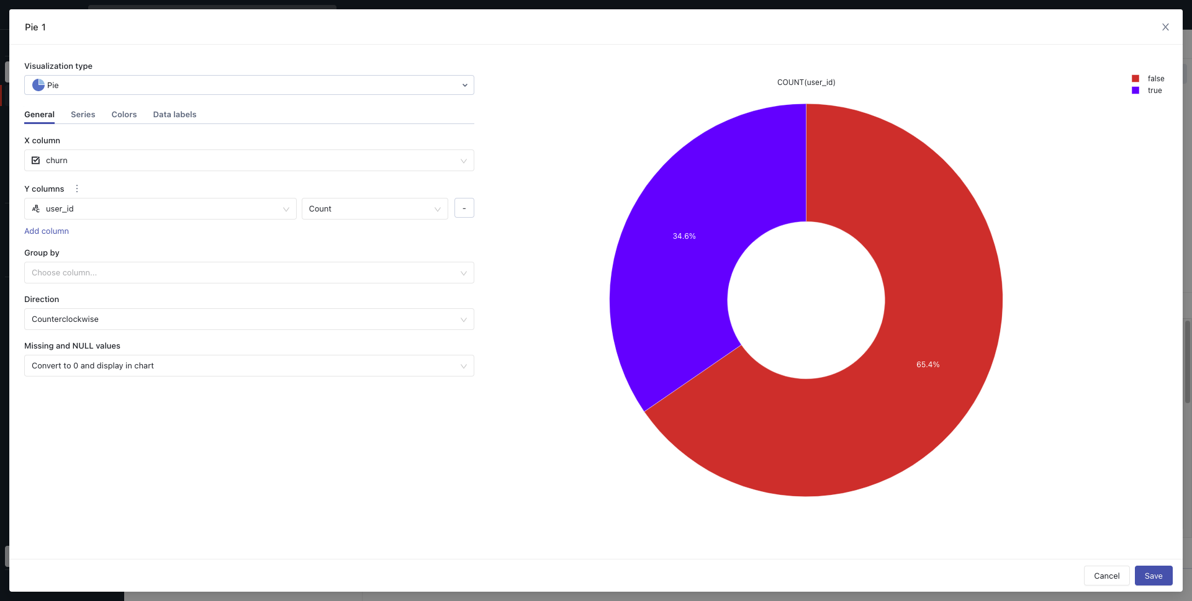

Step 15: Go back to Customer Churn - Universal Dashboard.
Conclude how easily the data team collaborated on the lakehouse platform to build this dashboard.
Remember the last step of the maturity curve: automated decision-making. We can automate targeted marketing mail to the most strategic customers.


Demo recording example:
Note that this recording is using the old demo content and will be updated soon.
However the demo narrative is similar (with the addition of UC).
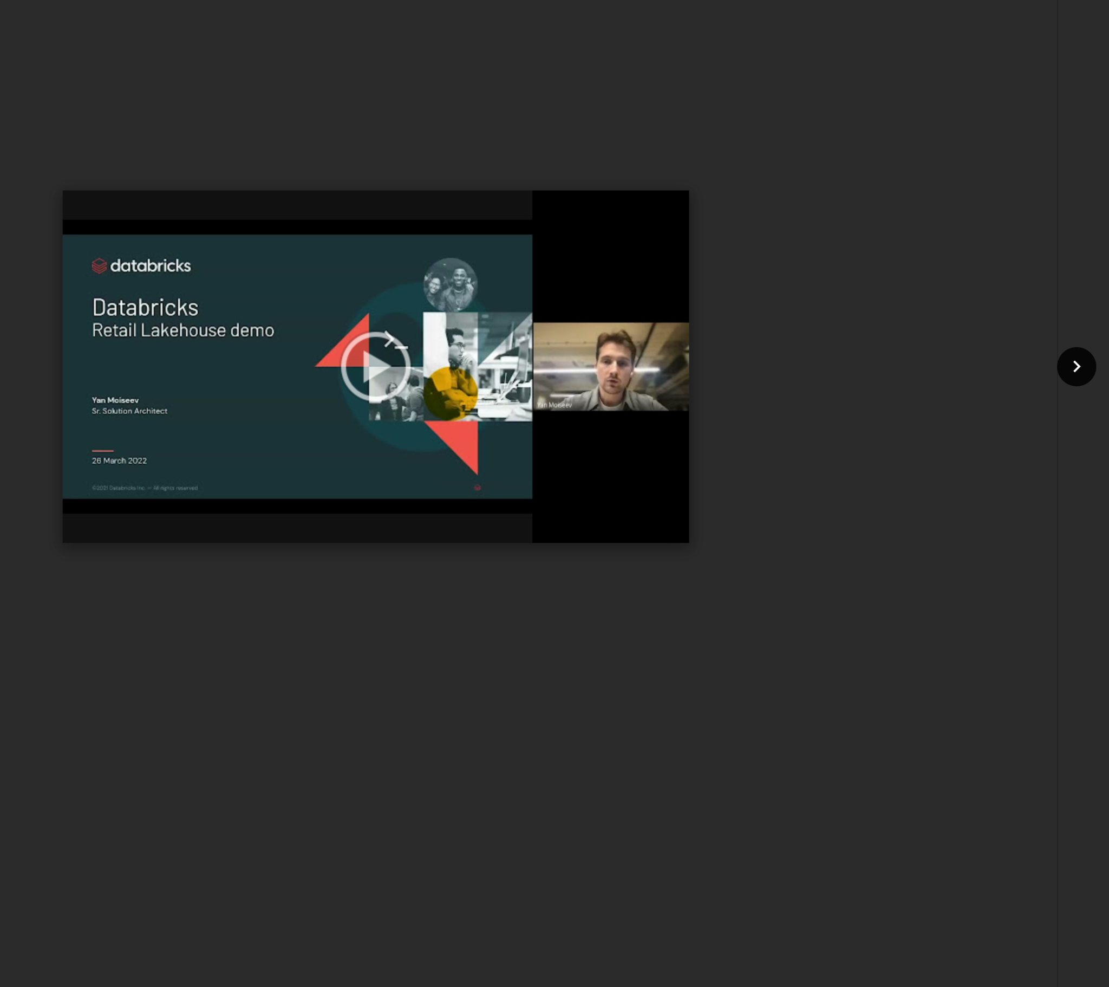
Access the video

Narrative points - slides:
Slide 2 - Data Maturity Curve
- Companies that do well are on the right hand side of the maturity curve.
- Left hand side of the maturity curve is a “given” in 2022, your competition is taking it further.
- Data Warehouses are great at the left part of it, Data Lakes are great at the right part of it. Lakehouses are great at both.

Slide 3 - Databricks Lakehouse Platform
- Simple, Open, Milticloud architecture. But why should you care?
  - Simple:
    - (1) Improved productivity, accelerate project delivery to business lines.
    - (2) Lower barrier of entry.
    - (3) Ability to tackle more complex use cases.
  - Open:
    - (1) Versatile partner and technology ecosystem.
    - (2) Lower vendor lock-in.
  - Multi-cloud:
    - (1) Consistent experience across clouds reduces cloud-vendor lock-in.
    - (2) Reliance on one cloud is an existential threat for some companies.

Slide 4&5 - OPTIONAL - You can skip those and introduce the retail context in Slide 3 instead - Lakehouse for C360 & Personalization
- (1) The lakehouse enables retailers to build out a customer 360 platform at scale.
- (2) Describe briefly from left to right citing a few data source examples and use cases.
- (3) Transition to the demo: Today we well focus on reducing customer churn.
Slide 6 - Demo: C360 Lakehouse for online retail
- For the demo, we’ll take the example of a retail company having experienced a revenue decline due to recent market events and competition. Our management determines we need to focus marketing efforts on the most strategic customers.
- Our team needs to ingest / train ML model / build predictive dashboards
Slide 7 - What it takes to implement a data project
- (1) DE, BI Analyst and DS missions to implement this data project
- (2) Different stacks/tooling lead to
  - siloed data -> implies data dependencies and costly data replication
  - Limit collaboration between, slowing use-cases time-to-production
- (3) Compliance risk as governance models are fundamentally incompatible

Slide 8 - The Lakehouse is simple
Bottom-up presentation

Narrative points - platform:

Component | Talking point | So what, who cares?
DBSQL - Dashboards | Built-in BI functionality, other BI tool pluggability. | Track your business metrics, data driven
DBSQL - Dashboards | Data coming from ML models and traditional BI metrics (Lakehouse). | Lakehouse architecture collides worlds of BI and AI without data and compute duplication.  Ability to support more complex use cases natively (the 2 parts of the data maturity curve, what happened/will happen).
Persona view | Same platform, but specialized for your task. | Lakehouse architecture allows you to perform multiple tasks within the same governance framework that would traditionally require different platforms.  Improved collaboration.
Repos | Native access control functionality. | Easy and powerful security mechanics at enterprise scale.
Repos | Git integration. | Native ability to plug repos into a CI/CD pipeline improves your productionisation velocity.
Notebook | Multi-language support. | Improves development productivity by giving them one tool to use instead of having to pick one language.
Clusters | Autoscaling. | Decoupled compute and storage, ability to scale them independently.  Improves scalability of the platform, helps control cost.
Clusters | Runtime / photon | Best spark engine, providing the best TCO to optimize cost / speed.  Maintains consistency between production and development, reduces development friction.
Data catalog | Unity Catalog | Single place to handle all your security/governance: table ACL, lineage, audit log and other objects like ML Models etc.
DLT - Code | Accelerate and simplify ETL development | Enable analysts and data engineers to innovate rapidly with simple pipeline development and maintenance. Build advanced workload in pure SQL.  Self-optimization and auto-scaling data pipelines for batch or streaming processing (TCO)
DLT - Code | Trust your data | Ensure accurate and useful BI, Data Science, and ML
DLT - Code | Automating complex administrative tasks and gaining broader visibility into pipeline operations | Remove operational complexity, Improve team efficiency
ML - MLFlow | Run / Registry view. | Model governance, regulation. Know what’s deployed where.
ML notebook | Databricks ML runtime/autoML/notebook/MLFlow… | The most advanced ML platform to simplify and accelerate your ML projects (from Lowcode to advanced DL projects)
ML - DLT | Running inference as DE | Value of the Lakehouse: can load ML model designed by another team and apply inference in batch or realtime to refresh dashboarding / data app
DLT - Pipelines | DAG UI. | Lineage, track dependencies for regulation / governance. Simple, accessible data pipeline for non-data engineer (data analysts)
DLT - Pipelines | Data Quality Dashboard. | Leverage the lakehouse to analyze your data and react when data quality changes, ensuring the right data is delivered to business lines.
Jobs | Schedule Jobs. | Databricks does not require an external scheduler, lowering the level of entry for users to productionize their work.

Evaluation Criteria:
See demo deck for the evaluation criterias

